HW 4 - COROUTINE AND RETROFIT - RACETRACK AND MARSPHOTOS

Saikumar
Quiz Score
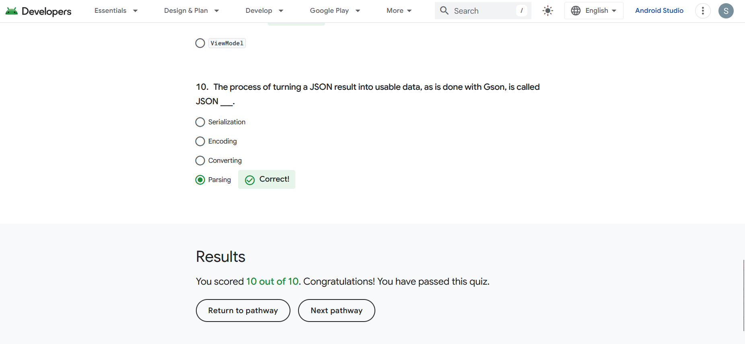
Figure 1: Quiz Score

Badges
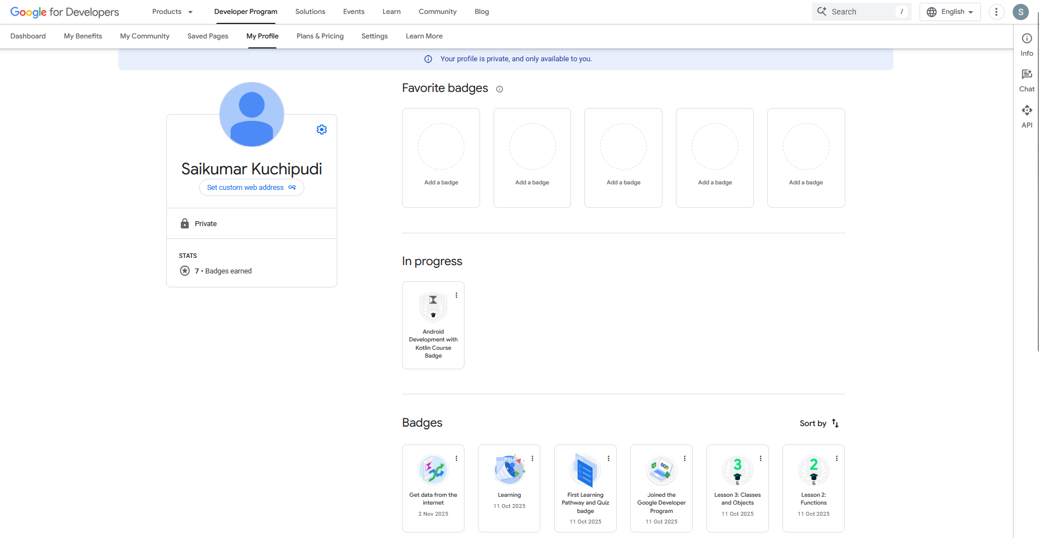
Figure 2: Badges form My Profile

